COMHAIRLE CHONTAE AN LONGFOIRT

LONGFORD COUNTY COUNCIL

Corporate Affairs,
Aras an Chontae,
LONGFOIRT.

9th June 2016.

Chuig: Gach Ball don Chomhairle.

A Chomhairleoir,

The Monthly Meeting of Longford County Council which was due to take place on Wednesday, 8th June 2016 was adjourned as a mark of respect to
Councillor Mick Cahill on the death of his Father, Mike, R.I.P.

The Adjourned June Meeting of the Council will take place on Wednesday, 15th June 2016 at 4.00 p.m. in the Council Chamber, Aras an Chontae.

Mise le meas,
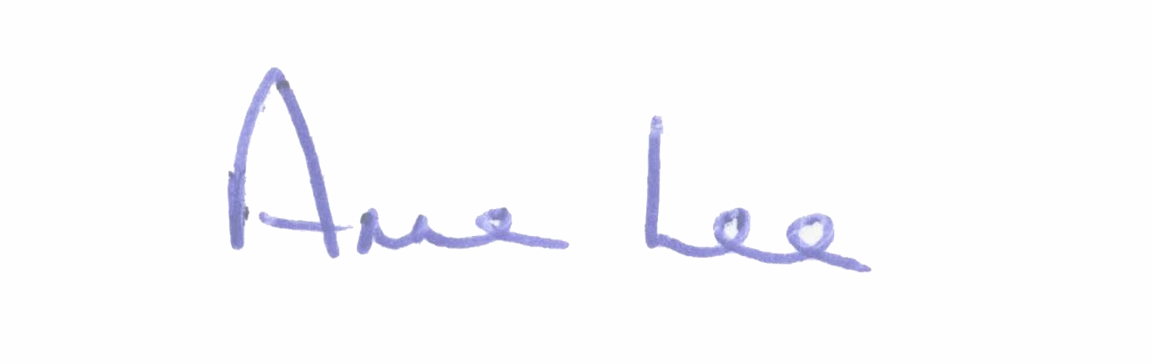

________________________
Anne Lee,
Meetings Administrator.

